Syllabus

Grade 8 English Mrs. Flamio

2022-2023

*Throughout the course of your 8th grade year*

*you will learn literacy skills necessary for college and career readiness. You will participate in a variety of learning activities including whole-class, pairs, independent and small group learning.*

**Required Supplies:**

*Blue/ Black Pens*

*Earbuds/headphones*

*Highlighters*

*2 composition notebooks*

*3 pads of different color Post- it notes*

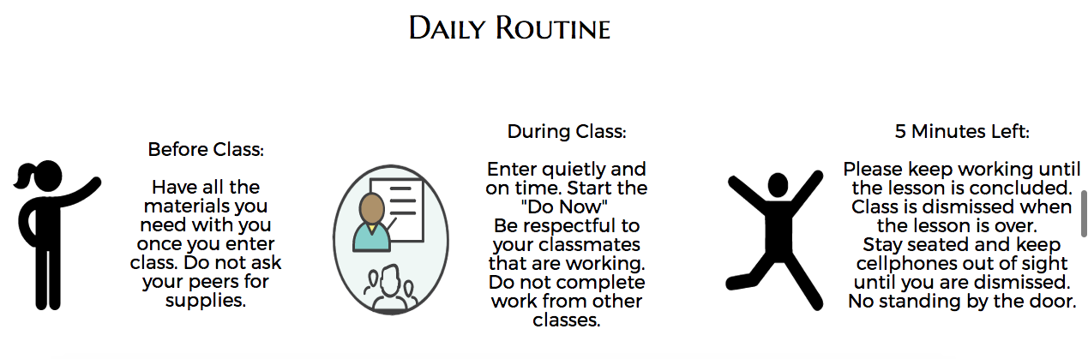

Grading Policy and Curriculum Pacing Guide

* Homework 10%
* Classwork 20%
* Test 25%
* Quizzes 20%
* Authentic Assessment 25%

All classwork must be completed the day it is assigned, unless instructed otherwise

Homework will only be accepted for a late grade the week it is due, but ten points will be deducted for each day it is late.

Tests and quizzes will be announced a few days prior.

Please take pride in your work and turn it in on time.

**Pacing Guide TBA**